**DATA VISULAIZATION IN TABLEAU**

Project Report

Executive Dashboard

Submitted By: Amit Kumar

Reg_no :11912201

Programme and section: B Tech. CSE(2019 batch) G3103

Course Code: INT233

Under the guidance of Richa Sharma mam (27957)

**Discipline of CSE/IT**

**Lovely School of Computer Science and Engineering**

**Lovely Professional University, Phagwara**



**Certificate**

This is to certify that Amit Kumar bearing Registration no. 11912201 has completed INT233 project titled, **“Executive Dashboard”** under my guidance and supervision. To the best of my knowledge, the present work is the result of his original development, effort and study.

**Signature and Name of the Supervisor**

**Designation of the Supervisor**

**School of Computer Science Engineering**

Lovely Professional University

Phagwara, Punjab.

Date: 21-11-2022

Declaration

I am grateful for my course faculty and the esteemed college indeed for assigning and assisting me with this great project for data visualization course

In the session 2022-23 .With this project i tried my best to provide a user-friendly easy to understand advanced interactive dashboard .

ETL : Data Extraction and Loading : Inbuilt data source used

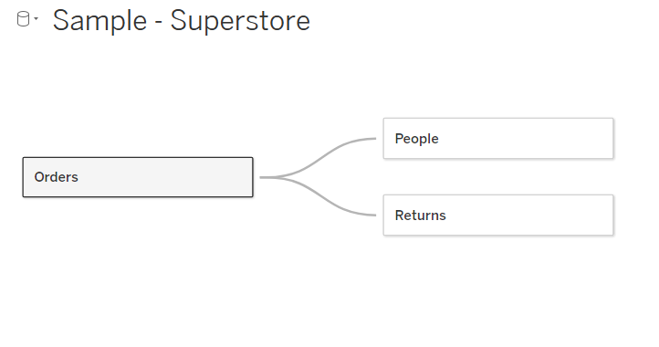

Dashboard View

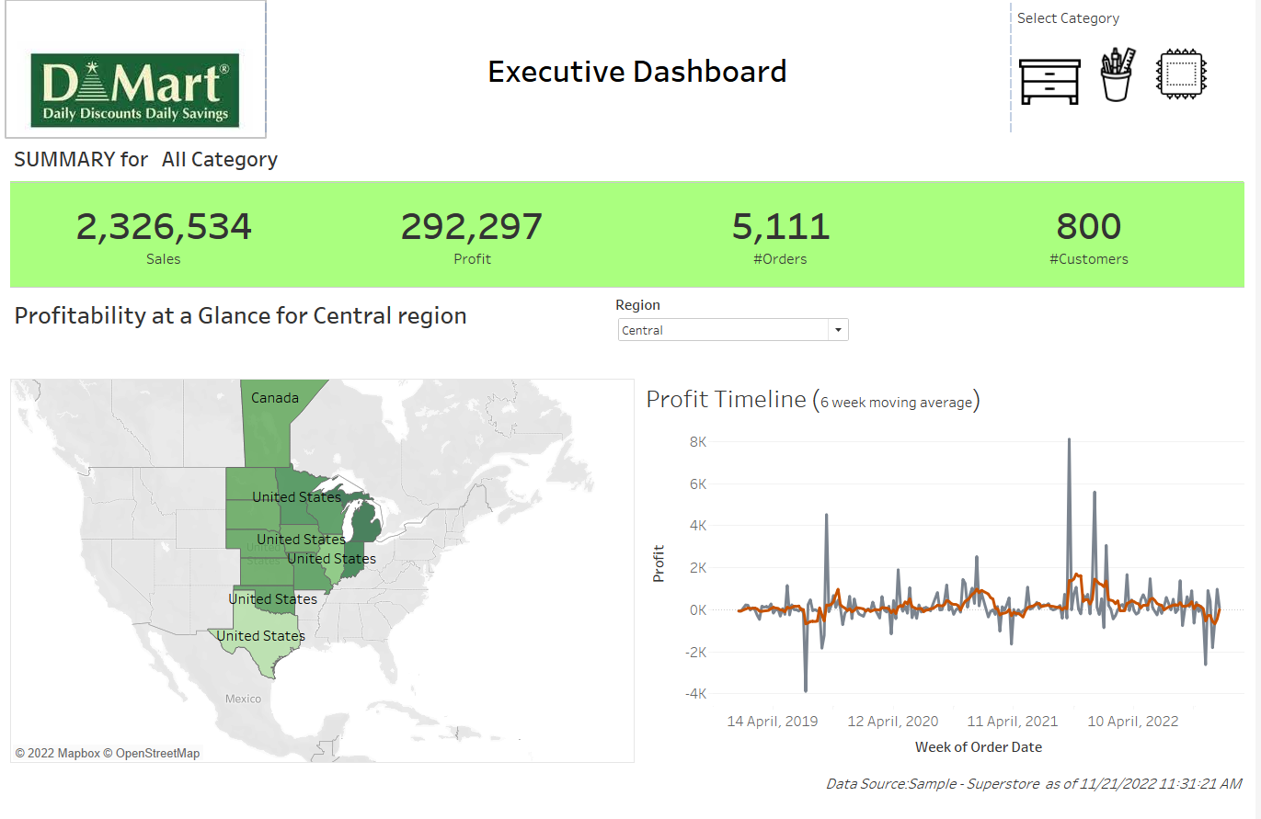

**Worksheet No. 1 : 01 Menu**

Icons were downloaded and stored at tableau repository as per given below path as:

Reason: As we want here icons for different categories as per our need

C:\Users\hp\Documents\My Tableau Repository\Shapes\custom categories

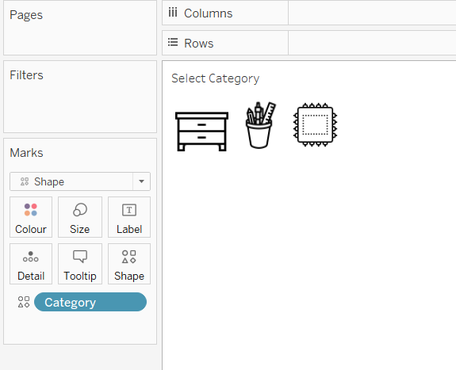

Select shapes-> then select the folder in which we have saved these there icon then assign the label name with icon appropriately.

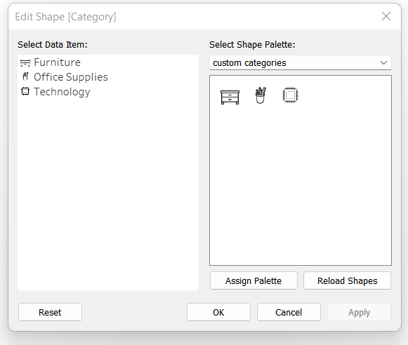

Worksheet 02 : 02 BAN

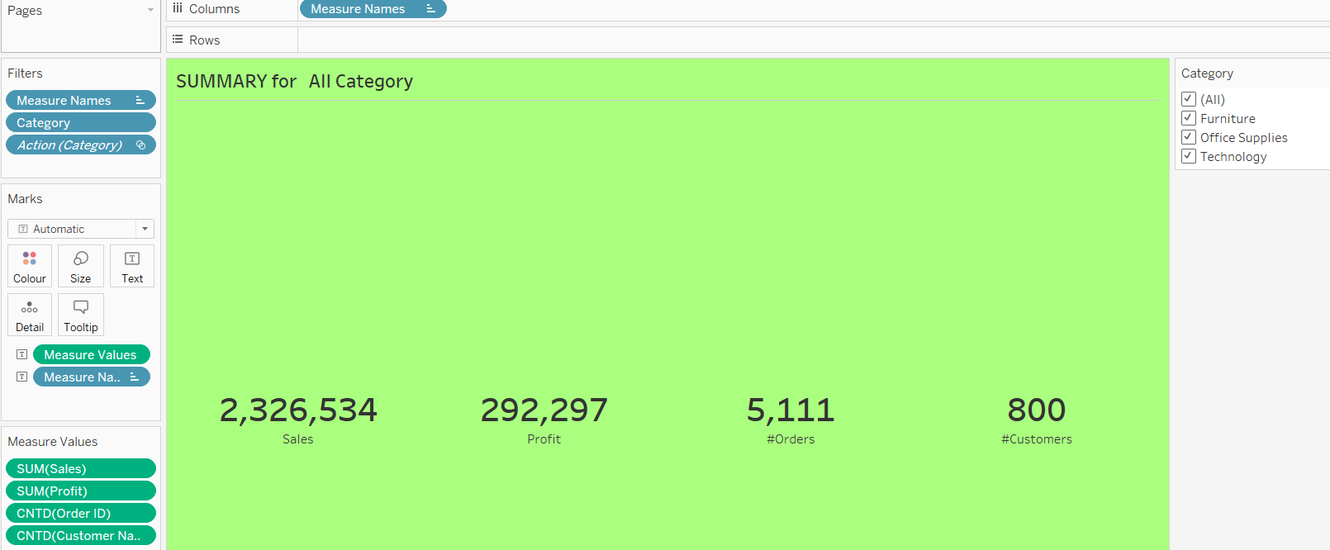

Here we have taken Measures Values as Sum(Sales) , Sum(Profit) CNTD(Order ID) which is basically tells unique order id’s and similarly CNTD(Customer ID) will tell unique customers ID’s

Using Format->shading we shade it with green colour

Removed Border by set Col Divider to none

Ser Row Banding to none

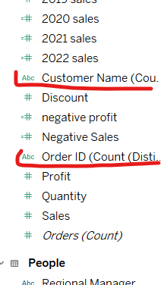

Worksheet : 03 Title

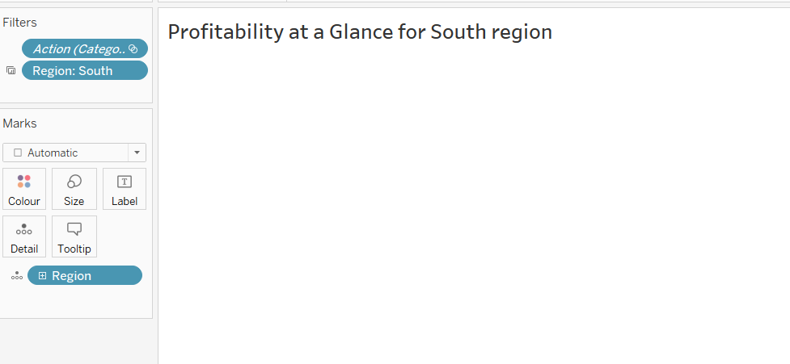

This basically is an **interactive label** above our profitability Map which will work in correspondence with the choices we select in a filter .

Here we have drag Region dimensions to details

From this page we want that region name will be pass on by filters we will introduced in the dashboard .

Worksheet: 04 profitability Map

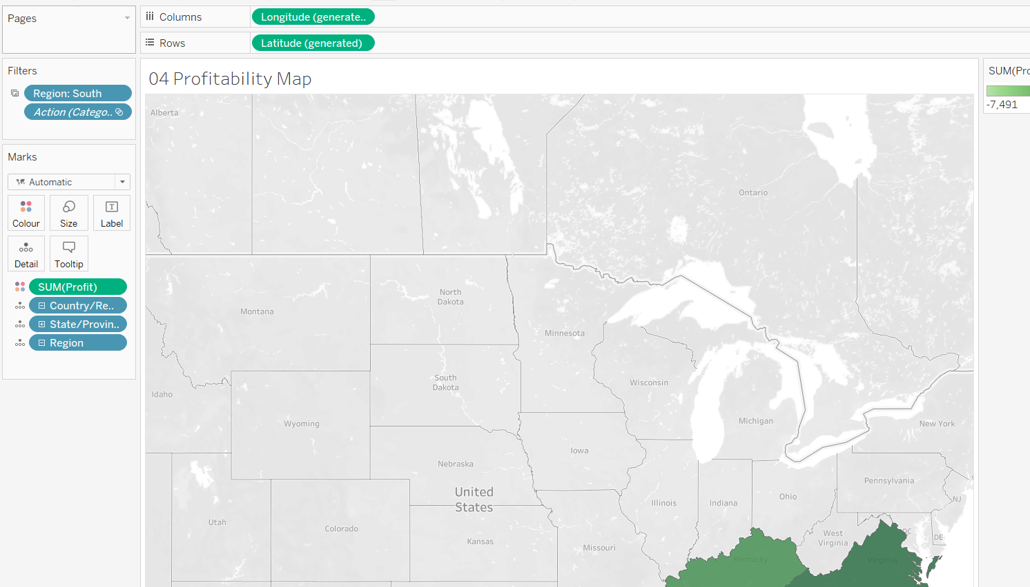

Sum of profit Country/Region wise is mentioned with sum of profit as colorblind green to

Show maximum profit region with denser color and light one with less profit.

Worksheet: 05 Profit timelime

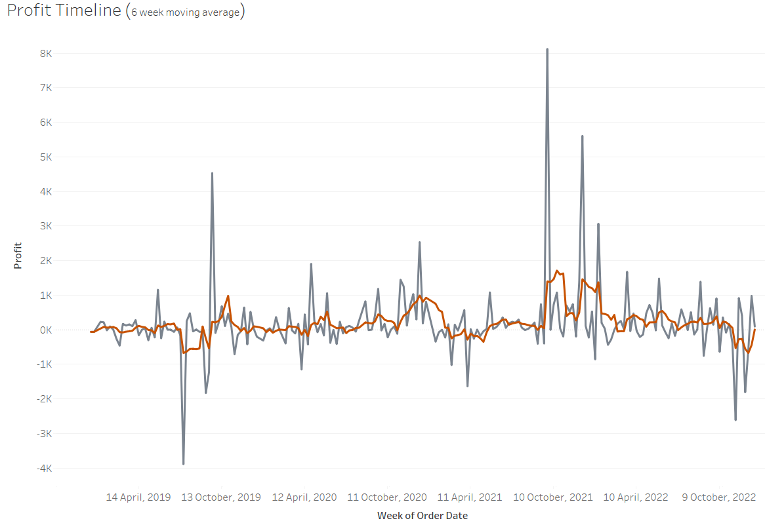

Shown two line chart one of them is Profit by Order Date(Week) by red line and another one is

Profit by Order Date(Week) here by editing table calculation to set average profit to 6 weeks

So average will be calculated by every 6 week shown here by Gray line

Workbook: 06 Footer

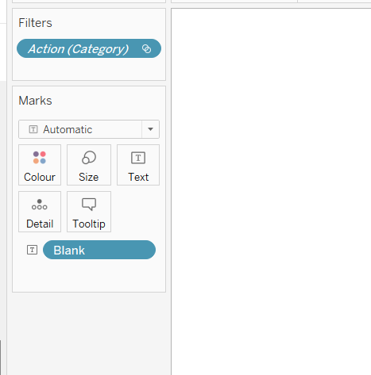

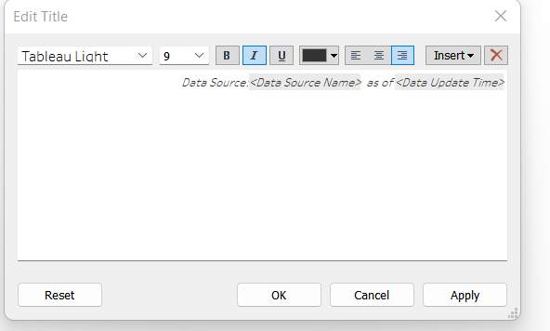

A blank calculated field is created as assign to text Marks

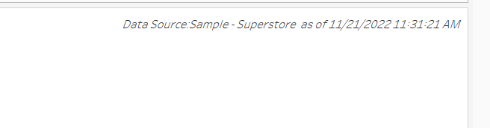

Dashboard window:

Above shown title get metadata like data source and data source data time

Placing the worksheet in containers horizontal and vertical after selection dashboard tab.

Remove unnecessary filters which came into existence by dragging sheet to container.

